How to use IQinVision ONVIF camera
How to use dual stream for Amegia camera
How to use HUNT ONVIF cameras
Event
Dual stream
How to use dual stream on Ingrasys iMege N3211E
How to enable ONVIF on ACTi cameras?
How to enable dual-streaming on EtroVision camera?
How to connect to A-MTK ONVIF camera?
Configuration for Motion Detection

How to use IQinVision ONVIF camera
In CameraSetup, StreamUseTCP must be set to yes to see the video.
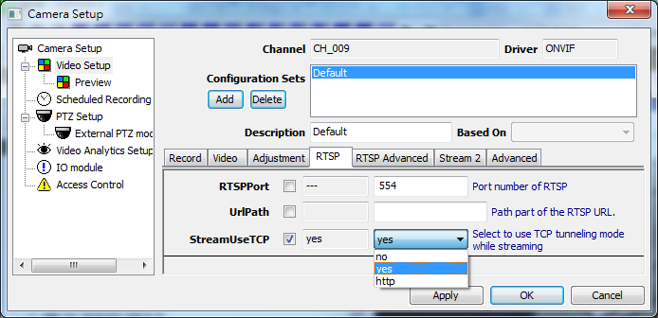

How to use dual stream for Amegia camera
Check Stream Enabled in Setup page
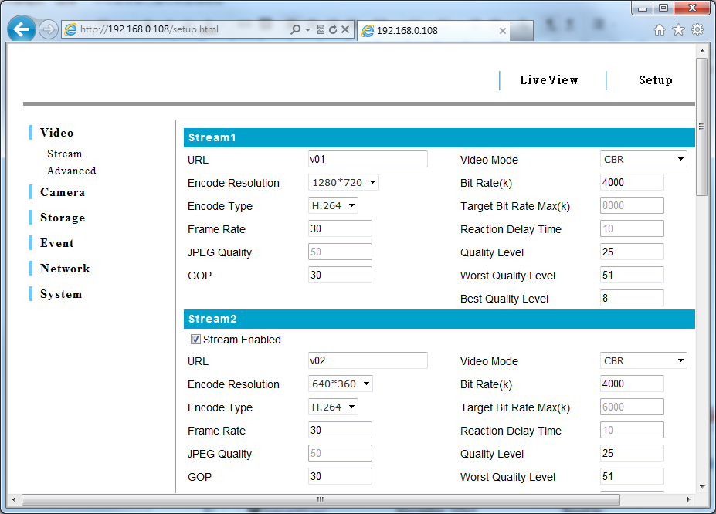

How to use HUNT ONVIF cameras

Event
Set PullMessageTimeout to PT20S
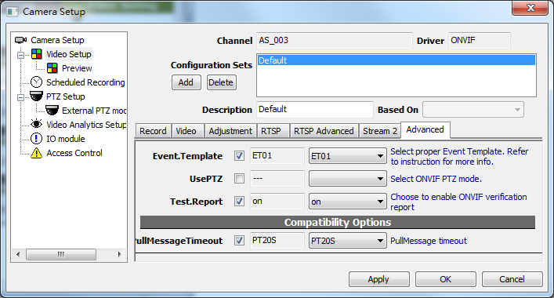

Dual stream
In Video Setting, enable Streaming 2
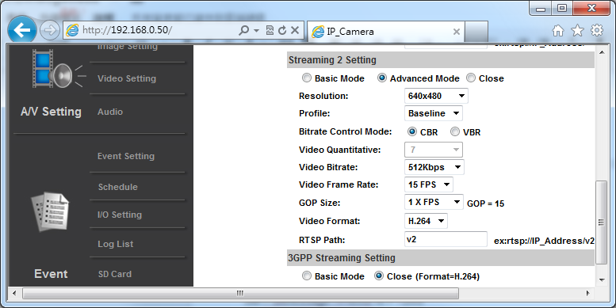

How to use dual stream on Ingrasys iMege N3211E
Stream 2 in Video Setting must be enabled
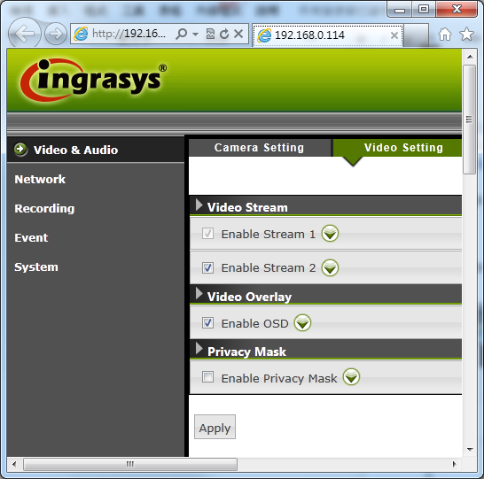

How to enable ONVIF on ACTi cameras?

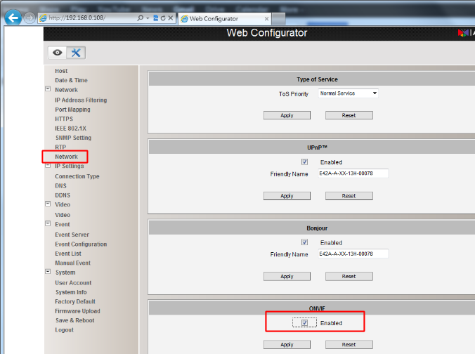

How to enable dual-streaming on EtroVision camera?
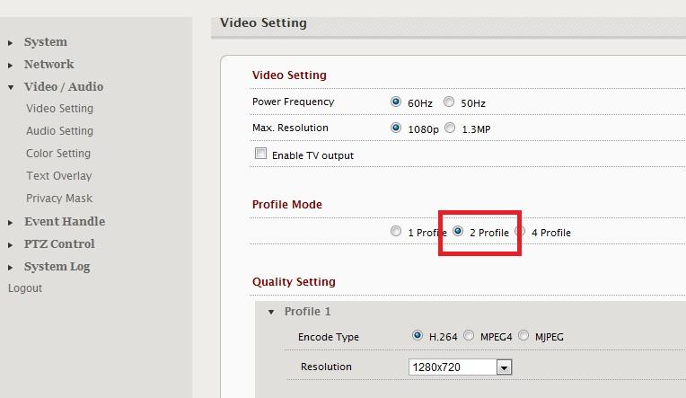

How to connect to A-MTK ONVIF camera?
The camera default username is “admin” and password is empty.

However for ONVIF function to work, the default username/password is different: “admin” for username, and “admin” for password.

Configuration for Motion Detection
Motion Detection works only if it's configured as following…
1. Set Type to Entrance
2. Set Max. Inspection Trigger Size to cover whole image
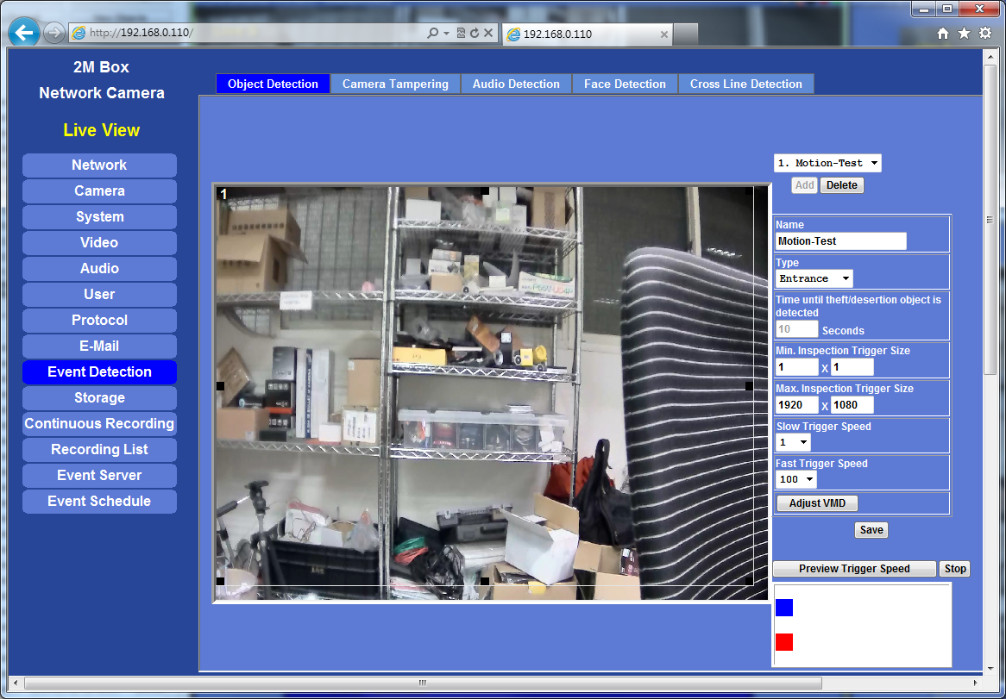

3. Set Min. Inspection Trigger Size to 36x36
