Manual for Camera Manufacturers
Community Platform Overview
Adding a brand in Community Platform
Editing brand name
Editing and previewing brand logo
Editing website
Adding camera series/model
Managing Camera Models
Editing camera attributes (features)
Editing and previewing image for camera model
Suggesting RTSP/ONVIF settings
Deeper SDK integration with Generic Camera Driver

Manual for Camera Manufacturers

Community Platform Overview
Community Platform is an initiative to improve global IP camera compatibility. By sharing IP camera connectivity information, you can contribute to the IP video community to help eveyone connecting to the same type of camera you're using. You also benefit from the knowledge shared by others. Visit our official website for more information: http://geniusvision.net/cp

Adding a brand in Community Platform
Click Camera Compatibility List in main menu...
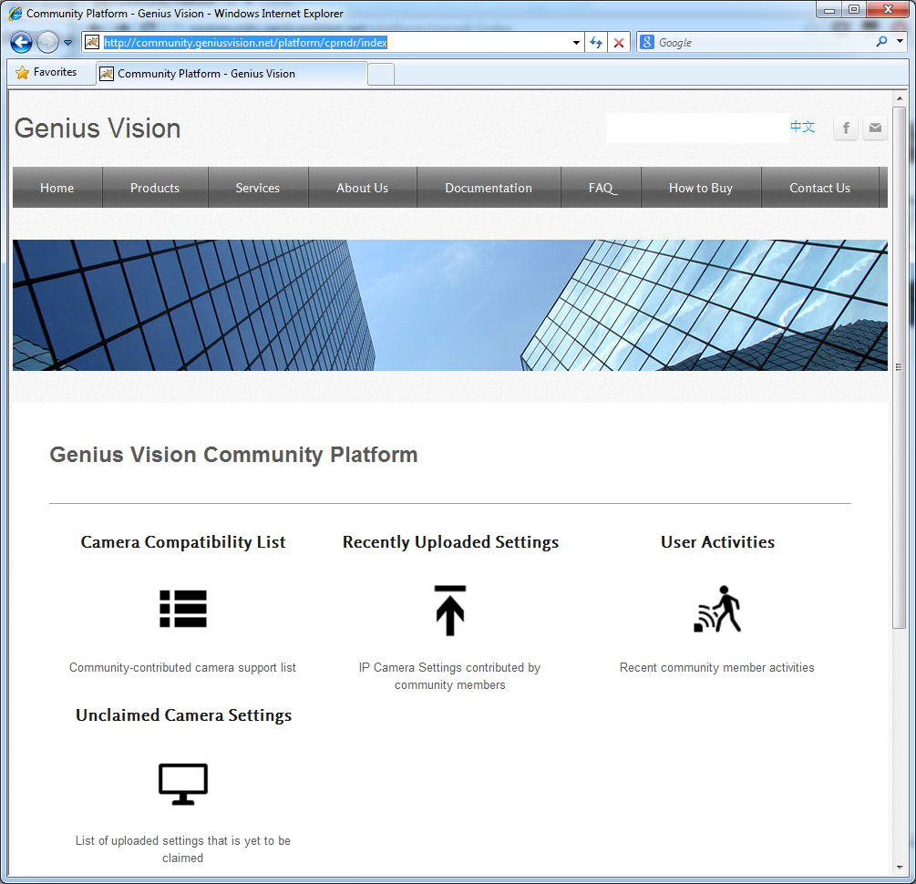

Click [Add manufacturer]...
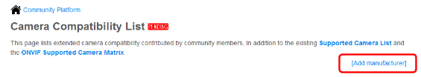
You need to sign in with either Google or Facebook account...
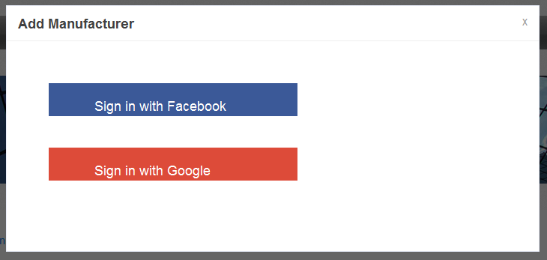

Input your brand name and click Add...
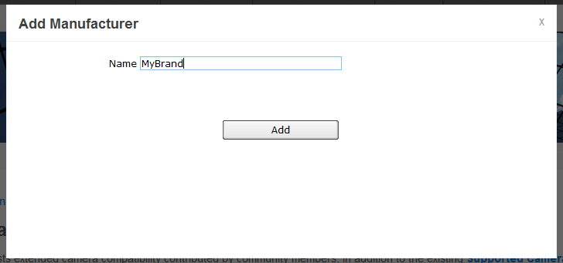

You see this message if your brand is added successfully. Other users can't see your brand yet before approval. You can still proceed to edit and manage your brand in Community Platform.
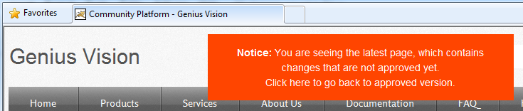

Click your brand in Camera Compatibility List and you see this…
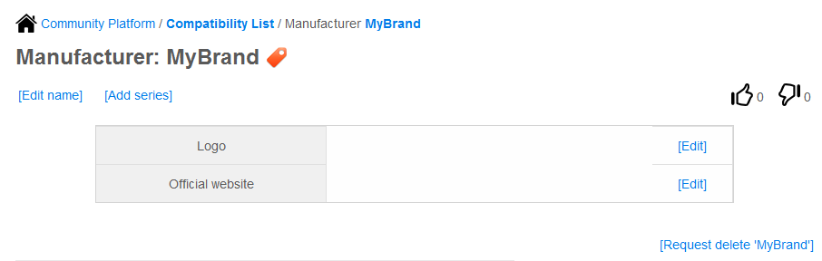

In this page you can:
- Edit your brand name
- Add/edit logo for your brand
- Add/edit website for your brand
- Add camera series/model
- Request delete your brand

Editing brand name
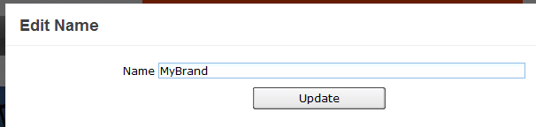

Editing and previewing brand logo
Enter a URL for your logo. You need to host the logo by yourself. The image won't be stored in Community Platform. So if the link is broken, users see broken image.
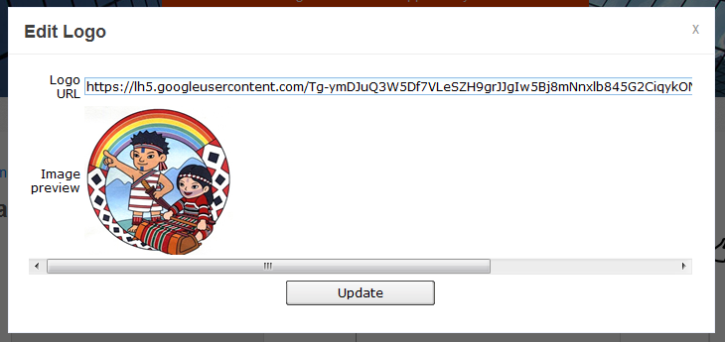

Editing website
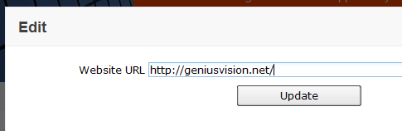

Adding camera series/model
You must add a series before you can add camera models. To add a series, click [Add series]...
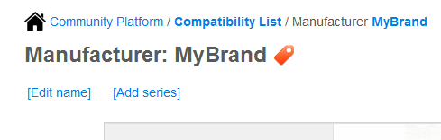

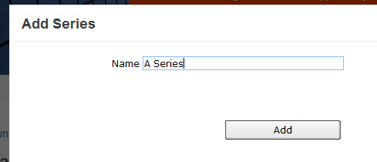

Now you can add model by clicking [Add model], or you can add sub-series.
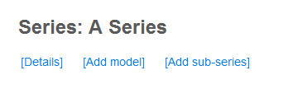

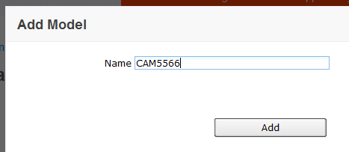

Your camera model is added successfully, now you can click it to edit/manage details for this model.
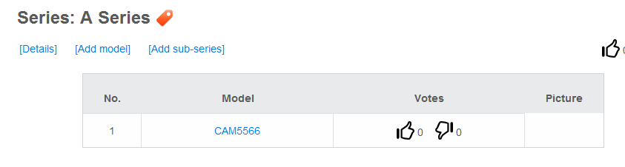

Managing Camera Models
For every camera model, you can:
- Add/edit attributes
- Add/edit image
- Suggest RTSP/ONVIF settings
- Link to camera settings (for NVR)

Editing camera attributes (features)
Camera attributes define functions, features, and spec of a camera model. Attributes are optional. They are not used by NVR software when connecting to cameras. They are just for users' reference.

Click [Add attribute] to add an attribute. Valid values depend on the item you selected.
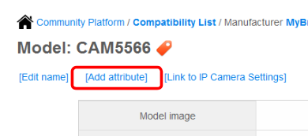
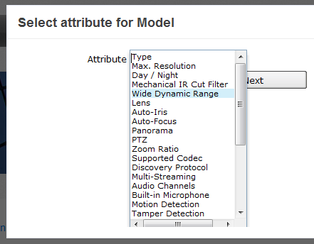
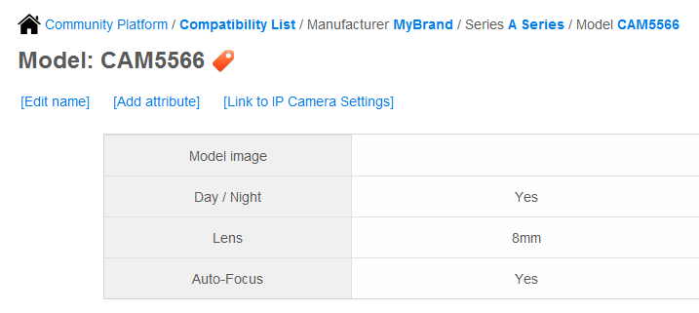

Editing and previewing image for camera model
Model image is just like manufacturer logo, input an image URL. Image preview can be displayed in Community Platform.
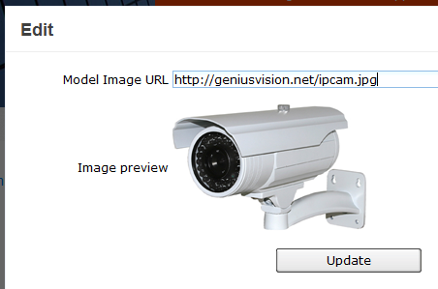

Suggesting RTSP/ONVIF settings
RTSP/ONVIF settings are downloaded by NVR software and used for connecting to cameras.
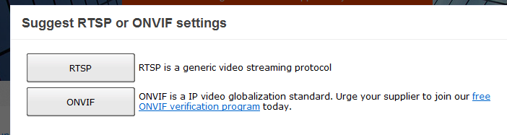

- You need to specify how you want to input RTSP URL before inputting it. URL is required for NVR software to request video stream from camera using RTSP protocol.
- Other parameters are optional. You may want to specify PacketBufSize if the data rate is high and broken image is expected. (See this FAQ entry)
- Default Username and password may also be required if the camera has more restrict authentication policy.
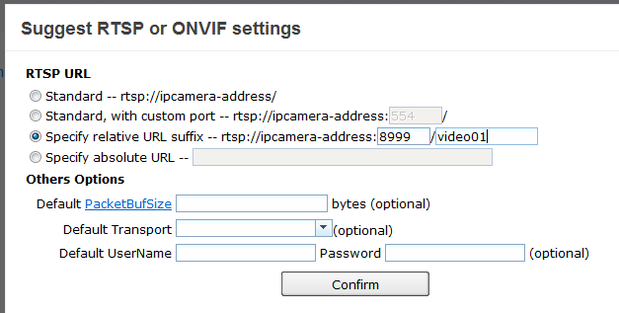

- For ONVIF, default HTTP port (80) usually works but it's not uncommon that a camera use 80 for web and other port for ONVIF.
- Username and password are usually required as ONVIF not only provides video streaming functions but also configuration.
- Event and PTZ are optional but you must specify them if you want to use these functions in Genius Vision NVR.
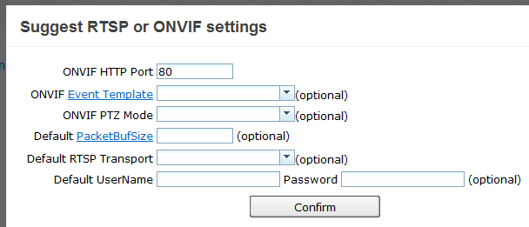

After you suggest settings and it's approved, users can see it in camera model page just like settings uploaded with NVR software. They can be downloaded/rated as well. So please try to make it correct, or users may feel frustrating when using these settings to connect to cameras in NVR software.
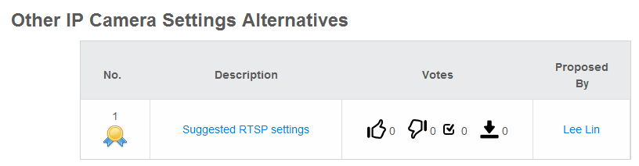

Deeper SDK integration with Generic Camera Driver
It is also possible to perform deep integration to custom camera SDK that opens the possibility to access to following functionality through Genius Vision NVR software. Refer "Generic Camera Driver Manual" for more details. You will also need to read "Community Platform Manual" to see how to upload camera settings to Community Platform from Genius Vision NVR software.

