Where can I sign-up for newsletter?
Can you integrate xxx model camera?
What are the suggested hardware specifications?
How can I provide my camera for testing?
What is the benefit to contribute to Example System?
How do I contribute to Example System?

Where can I sign-up for newsletter?
Like our Facebook page and you can get the latest information about Genius Vision NVR. In addition, you can share your experience there or ask for help, be it about our NVR or IP surveillance. We don't always have an answer but we will try our best. And there might be other users willing to help.
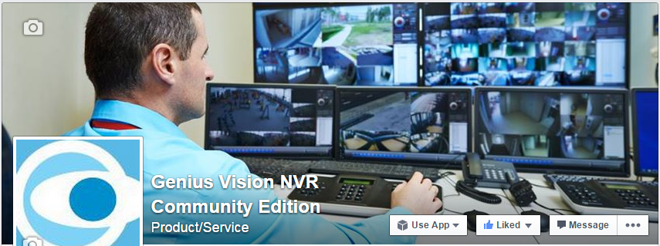

Can you integrate xxx model camera?
Genius Vision NVR has an unique feature called Generic Camera Driver that enables users to integrate cameras by themselves. Some technical background may be required but there is absolutely no coding. It's as easy as using RTSP URL to connect to an IP camera. Only with more functions and more manual reading. Please check our Generic Camera Driver Manual.

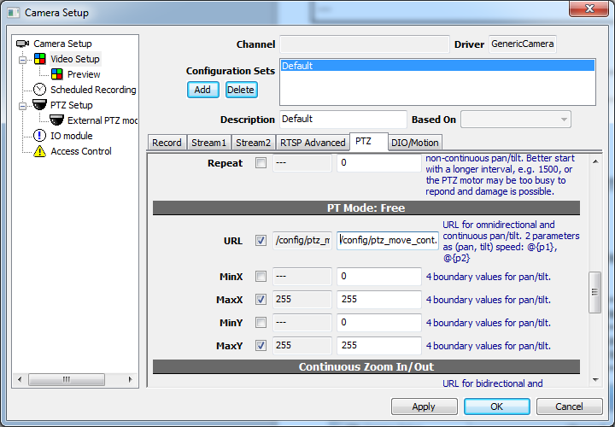

And don't miss our Community Platform. There're camera drivers for download. These are contributed by our helpful users. So if you integrate a camera with Generic Camera Driver, please share with the community.

Or you can send the camera to our lab. We might see what we can do about it. Please refer to How can I provide my camera for testing?

What are the suggested hardware specifications?
We don't suggest hardware. We test equipments and see what they can and cannot do. But different users may find different hardware suitable for their needs. So instead of suggesting hardware, we open the specs, configurations, and test results, for users to study and decide if the hardware is good for their applications.

How can I provide my camera for testing?
We need the camera to be in our lab for at least 6 months because 1. Integrate and testing takes time and 2. We are not always waiting to handle camera testing as there are other tasks. Please pay for the shipping fee in advance, if any.

What is the benefit to contribute to Example System?
As a user, contributing to Example System directly improves Genius Vision NVR. You can participate in our development and testing process to help NVR software evolves.

How do I contribute to Example System?
You can give us feedback about NVR software, NVR system architecture, or simply your experience with our software or other surveillance products. Furthermore, you can put equipments you like us to test in our lab, improving integration of our software and equipments.

See also
- What is the benefit to contribute to Example System?

