How to use unsupported camera in NVR software

New RTSP URL Directory for IP Camera
We've created a new RTSP URL directory for IP camera to help you connect to IP cameras, please visit:
- http://community.geniusvision.net/platform/cprndr/manurtsplist

Prerequisite
Most IP cameras and professional NVR softwares support RTSP (Real Time Streaming Protocol). As long as they do, you can use them together without worrying about compatibility. Check the spec (usually in Network section) to see if they support it.
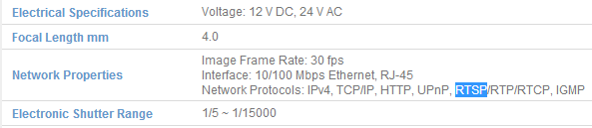

Find the cameras
Use the tool provided by IP cameras in bundled CD or online downloading to find the camera.
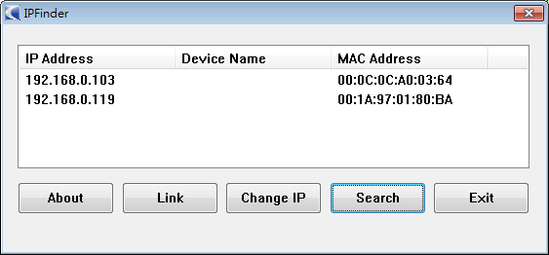

If they don’t provide such tool, try Windows network discovery instead.
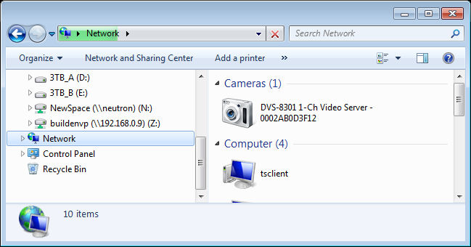

Find the RTSP URL path
Check the document (usually in RTSP section) for the URL path and RTSP port (usually 554).
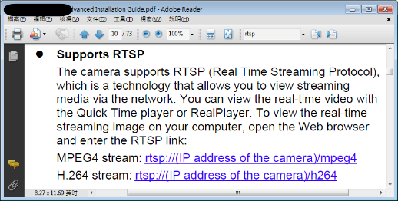

Add channel in NVR software
With the IP address and RTSP port and path, you can add it in most professional NVR software as an RTSP camera.
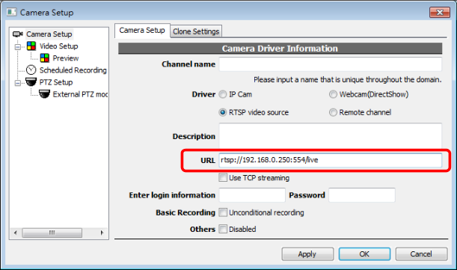

Setting the camera
Since the camera is not supported by the NVR software (that’s why we use RTSP at the first place), you cannot set parameters in NVR software. But most cameras have their own setting interface. Connect to the camera directly with internet browser and you can change the parameters.
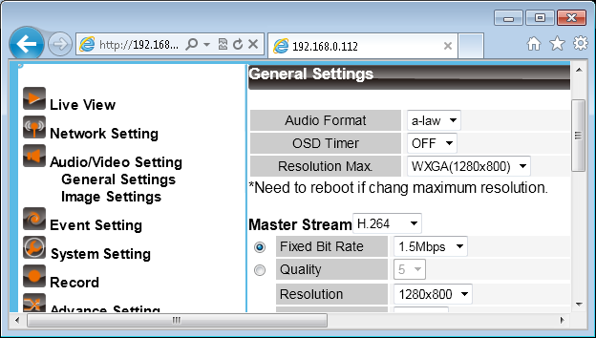

Keep in mind that some functionality still requires software integration to work, i. e., PTZ (pan/tilt/zoom), motion detection, IO port, audio output (talk)...

Troubleshooting
Follow the following steps to check if camera is working normally.
- Use PING to check network connectivity
- Use browser to check camera status
- Use RTSP client (other than NVR) to check RTSP streaming

Check network connectivity
Press Windows Key + R to invoke Run dialog and input ‘ping [IP address]’.
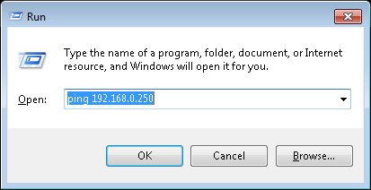

The following result should be seen. If it’s unreachable or time-out, you have to check connection or camera status.
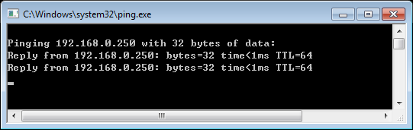

Check camera status
Use internet browser to check if the camera is working normally. Keep in mind that,
- This usually uses proprietary protocol so RTSP is not guaranteed to work even you see video in browser
- Some cameras only support Microsoft Internet Explorer
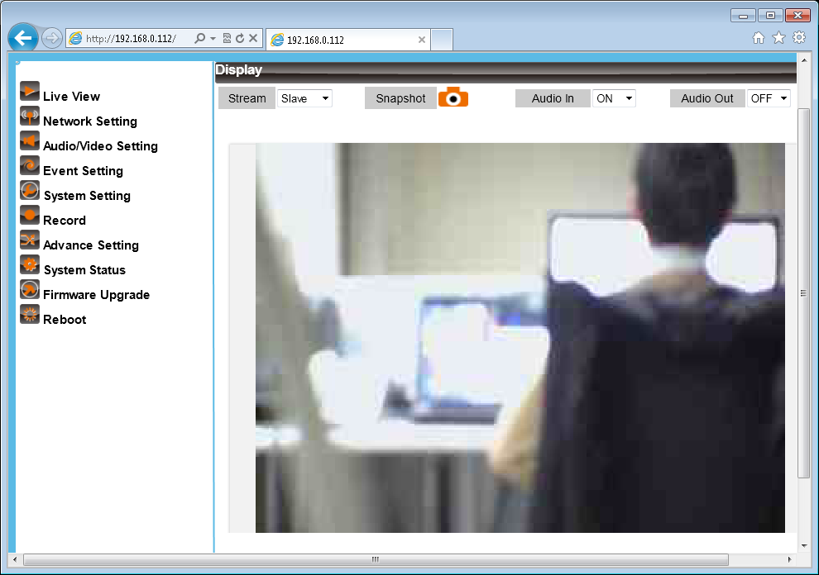

You will probably be prompted for username and password. In some cameras this credential information is also required for RTSP streaming.
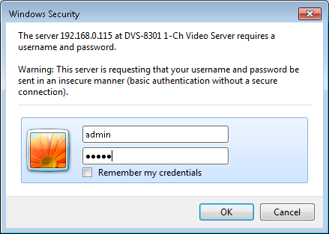

Check RTSP streaming
Use one of the following tools to check RTSP streaming. This is also helpful to verify RTSP port and URL path.
- VideoLAN (VLC)
- QuickTime Player
- RealPlayer

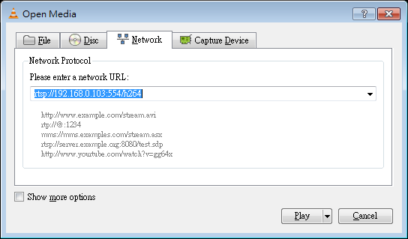

Still can’t get it to work
- RTSP is not internet friendly protocol. If you want to connect to the camera through internet, you have to try the TCP/HTTP streaming setting in NVR. Or you probably have to tweak your router.
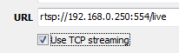
- Even camera and NVR software both support RTSP, there’s still a chance that they are not compatible. This is due to the complexity of RTSP or video codec such as H.264.

