Product Introduction
Ordering Info: NH267-16
NH267-16 Technical Specification
Features
Instructions
1-to-16 Audio-Video Cable
16-channel Capture Card Connection Example
Installing Driver
System Requirements

Product Introduction

Ordering Info: NH267-16
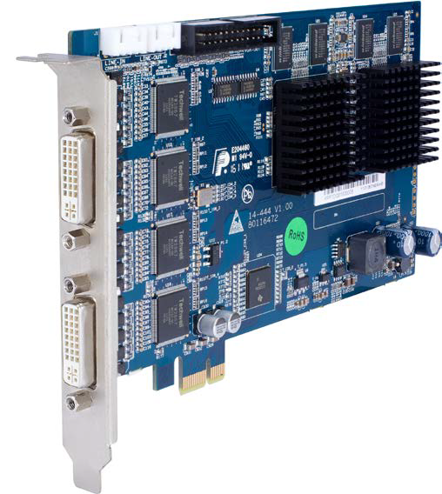

NH267-16 Technical Specification
PCI-E | PCI-Ex1 2.0 compliant
Dimensions(mm) | 175 ×106.6
Power consumption | 12W
Video compression | H.264, NTSC/PAL
Number of video input | 16
Video input connector | BNC(1.0Vp 1.0Vp，75Ω)
Preview resolution | D1
Recording resolution | CIF/D1
Encoding FPS per channel | 1~25 PAL, 1~30 NTSC
Encoding FPS per card | D1 16-channels max 480 FPS per card for NTSC, 400 FPS for PAL
Dual Encoding FPS | D1+CIF 16-channels max 480+480 FPS per card for NTSC, 400+400 FPS for PAL
Audio compression | G.711A
Number of audio input | 16
Audio input connector | BNC(2.0Vp 2.0Vp 2.0Vp-p，1000Ω ，audio volume control range 83DB)
Audio sampling rate | 8kHZ

Features
- Audio and video hardware compression card, using advanced standard H.264 video compression algorithm to achieve excellent image quality and high compression ratio.
- Support up to full D1 realtime live view
- 16 channel full D1 video real-time (total 480 FPS for NTSC, 400 FPS for PAL) compression and dual-stream.
- Support maximum dual stream D1+CIF for all 16 channels, both in real-time hardware compression, providing total 480+480 FPS for NTSC, 400+400 FPS for PAL.
- 16 channel G.711 audio compression.
- Support motion detection and video loss function; support OSD, text overlay, video frame rate, frame rate dynamic setup and etc
- Standard PCI PCI-E 1X slot.

Instructions

1-to-16 Audio-Video Cable
Applicable to 16-channel capture. 8 black cables are video channel VID1~VID8.
8 blue cables are audio channel 8 AID1~AID8.
You need two 1-to-16 Audio-Video Cable for 16-channel capture card to get total 16-video and 16-audio.
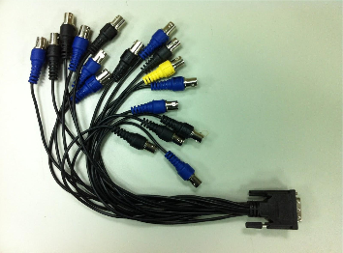

16-channel Capture Card Connection Example
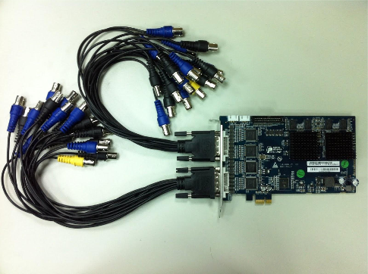

Installing Driver
Please get driver from this location. This driver is only applicable for Windows 7 32-bit.

Open Windows “Device Manager” and locate “Multimedia control card” inside “Other devices”. If it’s 16-channel capture card, you will have to such devices. Right click to invoke context menu and select “Update driver”.
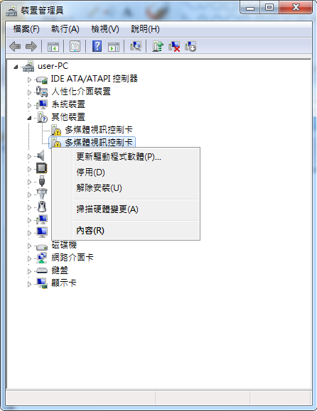
Select “browser for driver...”
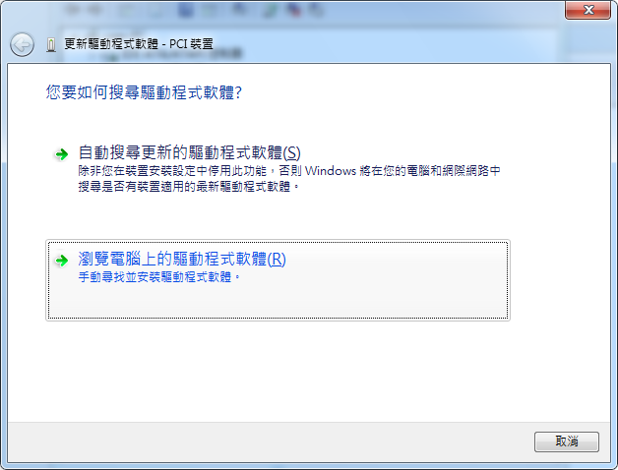

Select the directory that contains downloaded driver.

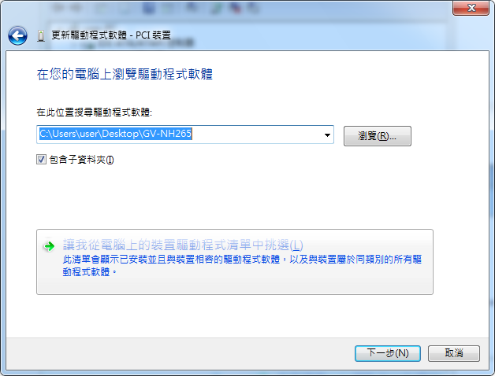
If you experience any unsigned driver warning, select “install anyway”.
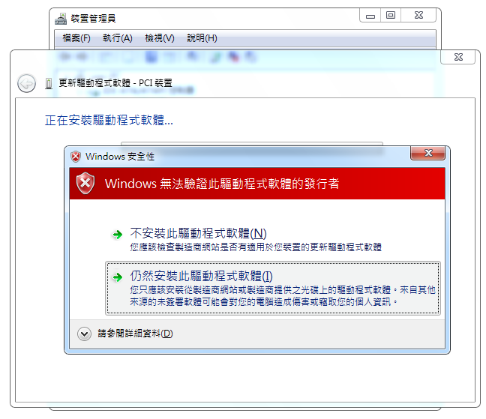

For 16-channel capture card, you need to update driver for both devices. When you see the following message, it means the process is completed. The device might not be usable right away and you need to reboot.
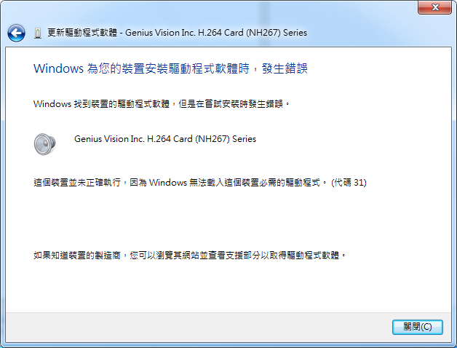

After rebooting, open Device Manager to examin if both device are installed properly:
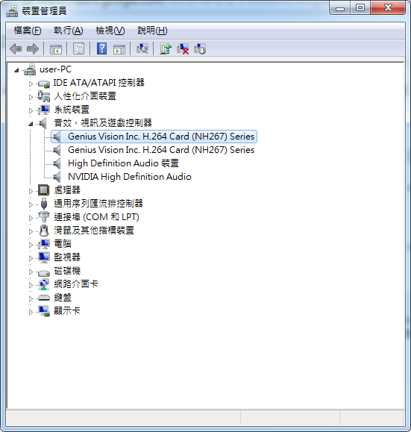

System Requirements
- Windows XP/7 32-bit

