NH267 Series OS Support List and Driver Download
Driver Installation Steps

NH267 Series OS Support List and Driver Download
OS name | Testing | Driver
Windows XP 32-bit | Not tested | 32-bit Windows Driver
Windows Vista 32-bit | Not tested | 32-bit Windows Driver
Windows 7 32-bit | Tested | 32-bit Windows Driver
Windows 8 32-bit | Only preliminiarily tested | 32-bit Windows Driver
Windows 2003 Server 32-bit | Not tested | 32-bit Windows Driver
Windows 2008 Server 32-bit | Not tested | 32-bit Windows Driver
Windows XP 64-bit | Not tested | 64-bit Windows Driver
Windows Vista 64-bit | Not tested | 64-bit Windows Driver
Windows 7 64-bit | Not tested | 64-bit Windows Driver
Windows 8 64-bit | Only preliminiarily tested | 64-bit Windows Driver
Windows 2003 Server 64-bit | Not tested | 64-bit Windows Driver
Windows 2008 Server 64-bit | Not tested | 64-bit Windows Driver

Driver Installation Steps
Please obtain driver according to the above table and unzip the file into your computer.

Open Windows “Device Manager” and locate “Multimedia Video Controller” inside “Other devices”. If it’s 16-channel capture card, you will have two such devices. Right click to invoke context menu and select “Update Driver Software...”.
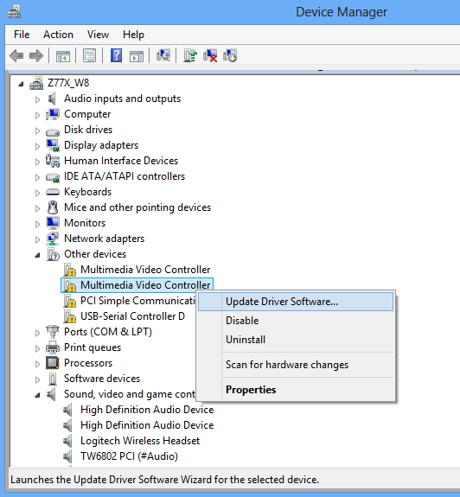
Select “browser for driver...”

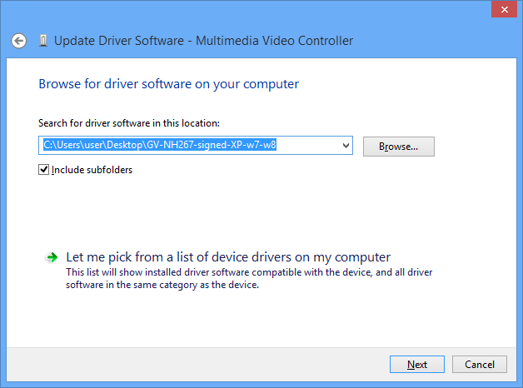
Following security notice might appear, select “Install”.

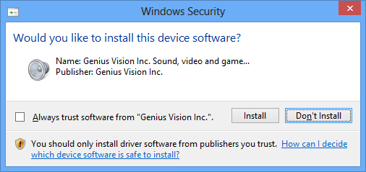
For 16-channel capture card, you need to update driver for both devices. When you see the following message, it means the process is completed. The device might not be usable right away and you need to reboot.

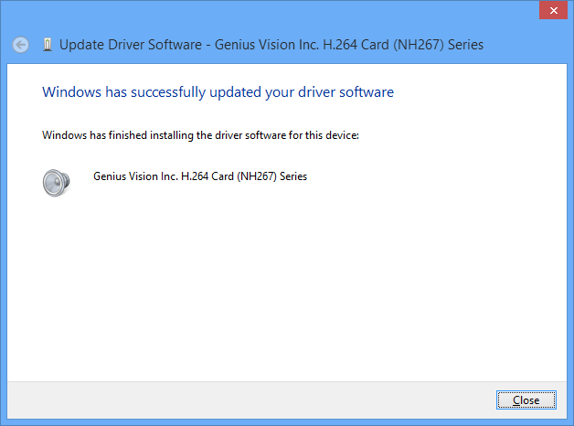
After rebooting, open Device Manager to examin if both device are installed properly:
