IQinVision
How to configure IQeye H.264 stream
A-MTK
How to enable two-way audio?
How to enable DI/DO?
How to enable on-screen PTZ?
JVC
How to support JVC VN-V25 and VN-X35, and VN-V685U, VN-686U, VN-686
Setting up VN-V685U, VN-686U, VN-686
Setting up VN-V25 and VN-X35
AirCam (Ubiquiti)
Configuring Ubiquiti AirCam using RTSP
Instructions
Brickcom
How to configure Brickcom Cameras?
Streaming Mode Selection HTTP
RTSP Configuration

IQinVision

How to configure IQeye H.264 stream
Although we do support IQeye camera, the integration took place years ago and at that moment IQeye only provides M-JPEG streaming. Nevertheless you can use RTSP configuration to see H.264 streaming, as illustrated below:
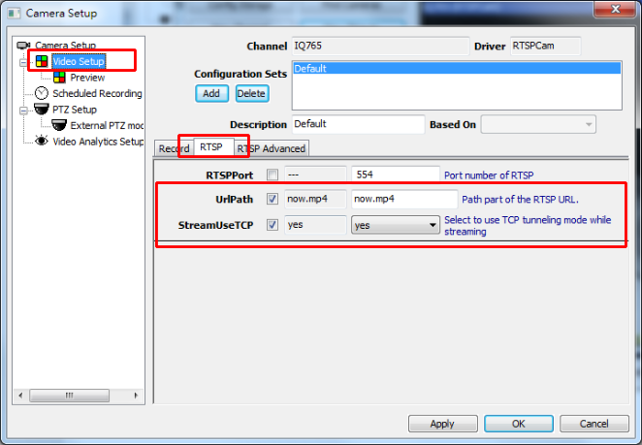

A-MTK

How to enable two-way audio?
Camera setup
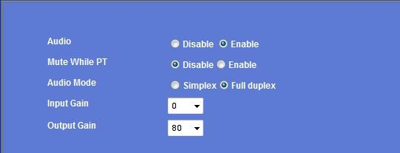

Software setup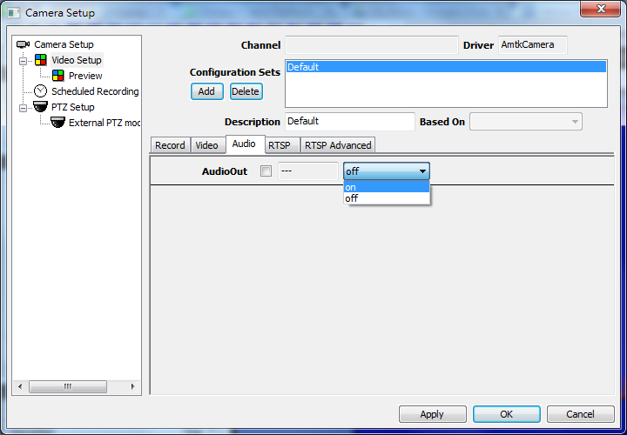

How to enable DI/DO?
Software setup: Please choose polling interval and the function will be enabled.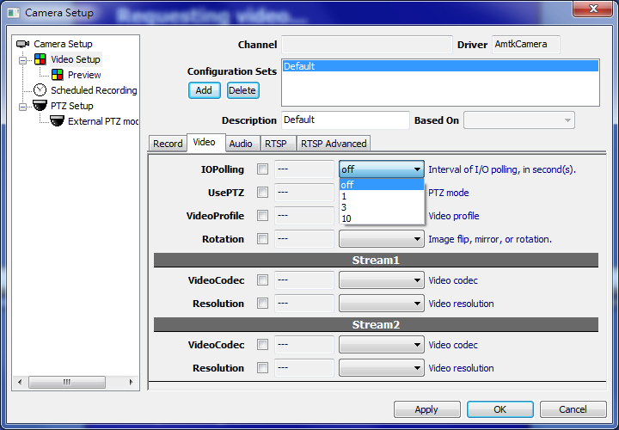

See also
- User manual - IO polling

How to enable on-screen PTZ?
Software setup: Please select PTZ control mode. There are two modes available.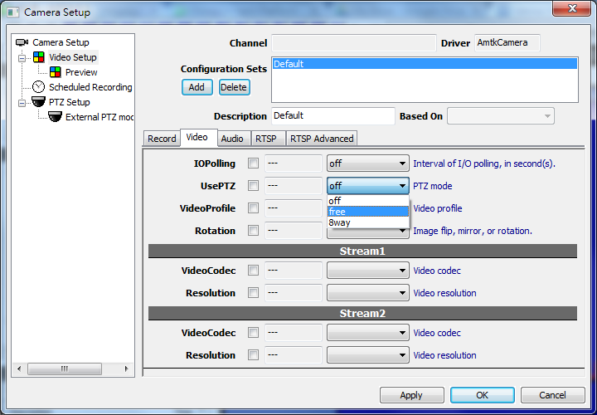

See also
- User manual - PTZ (Mechanical)

JVC

How to support JVC VN-V25 and VN-X35, and VN-V685U, VN-686U, VN-686

Setting up VN-V685U, VN-686U, VN-686
VN-V685U, VN-686U, VN-686 uses a new driver called "VNetworks2", for better implementation.
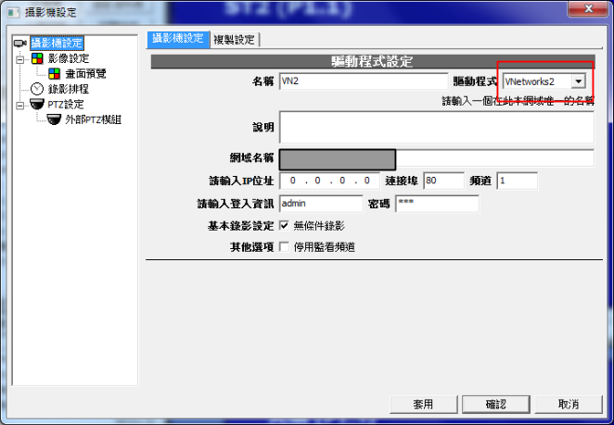

To enable click-on PTZ, do the following setup:
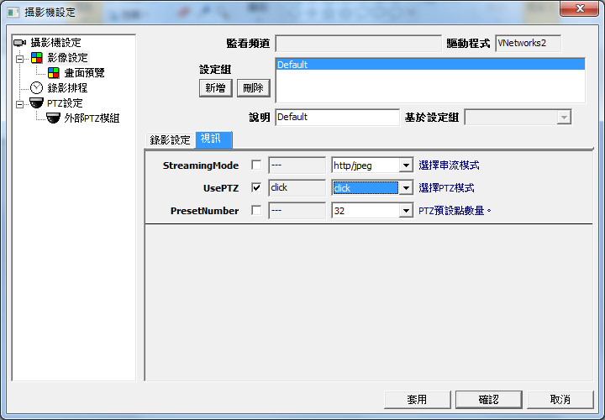

Setting up VN-V25 and VN-X35
VN-V25 and VN-X35 uses a different set of API VN-C38U and VN-625U used. In order to support these 2 models, you need to upgrade to a newer version and perform following configuration (Video Setup):

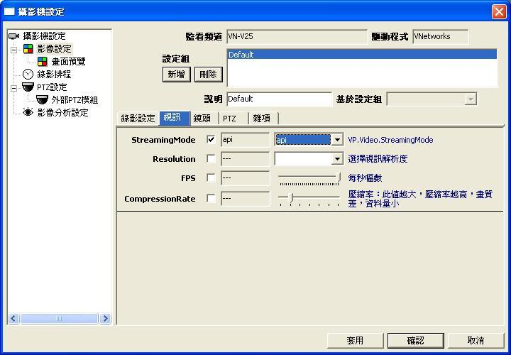

AirCam (Ubiquiti)

Configuring Ubiquiti AirCam using RTSP

Instructions
Thanks for Alex Arnold's effort to provide the instruction about how to connect Genius Vision NVR to Ubiquiti AirCam.
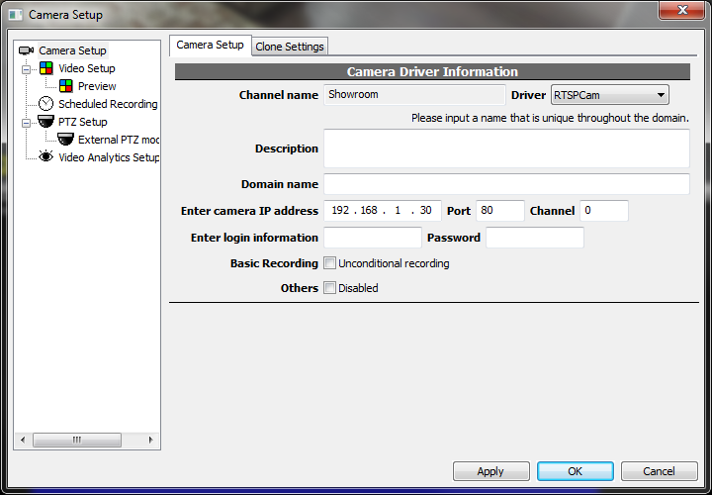

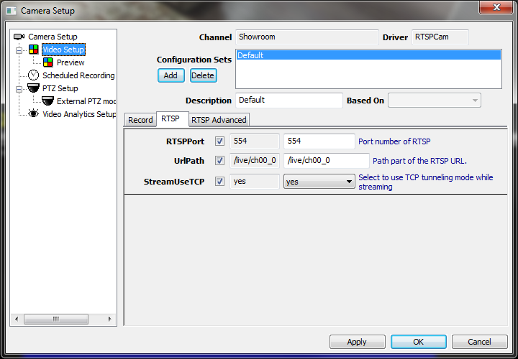

Brickcom

How to configure Brickcom Cameras?

Streaming Mode Selection HTTP
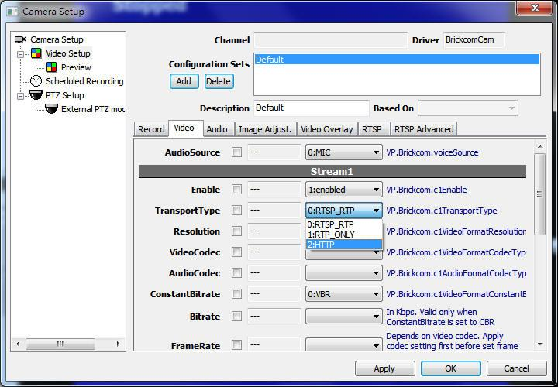

RTSP Configuration
